



**SM6P07NI Digital Media Project**

**20% Report**

**2024-25 Autumn**

**Student Name: Roman Shrestha**

**London Met ID: 22067419**

**College ID: np01mm4a220095**

**External Supervisor: Aashra Maharjan**

**Internal Supervisor: Bijay Shakya**

**Assignment Due Date: Wednesday, May 7, 2025**

**Assignment Submission Date: Wednesday, May 7, 2025**

**Word Count: 2711**

|  |  |
| --- | --- |
| **YouTube link** | [**https://youtu.be/PldIZYE5xhg**](https://youtu.be/PldIZYE5xhg) |
| **One Drive link** | [**DMP**](https://islingtoncollegeedunp-my.sharepoint.com/:f:/g/personal/np01mm4a220095_islingtoncollege_edu_np/EiEgKddGAcpEpaORzPeflM4BsWbeP-poqgYOEagY1C2OUw?e=1sHTsd) |
| **Git Hub link** | <https://github.com/Roman220095/Project-file> |

*I confirm that I understand my coursework needs to be submitted online via Google Classroom under the relevant module page before the deadline in order for my assignment to be accepted and marked. I am fully aware that late submissions will be treated as non-submission and a marks of zero will be awarded.*

Abstract

This project report outlines the entire process of creating an animated awareness film on 'Dengue'. It contains introduction, topic, area of study, identification of client, project objectives, target audience, product research, technologies used, project timeline, pre-production, production, post-production, resources, problem encountered, user test and outcome, conclusion, references, and appendix.

The processes and procedures utilized from start to finish, such as concept formation, script writing, storyboarding, designing, editing, compositing, testing, and rendering, are also outlined in this article. Supervisor and consumer satisfactions, individual performance, and in-depth preparation were utilized to produce the general idea instructional video. Therefore, the finished awareness cartoon video was used to test through surveys and audience reactions to validate its authenticity.

**Contents**

1. Introduction 0

1.1 Topic 2

1.2 Area of Research 2

2. Aims of Project 3

3. Target Audience 4

4. Product Research 5

5. Technologies Employed 8

6. Project Plan 9

7. Production Phases 10

Pre-production 10

Script 10

Storyboard 13

Production 19

Designing 19

Layout 19

Rigging 19

Animation 19

Post-production 19

Editing 19

Sound 19

Rendering 19

8. Resources 20

Software used 20

Hardware used 21

• Laptop 21

• Graphic tablet 21

Website used 21

9. User Testing & Findings 22

10. Conclusion 26

11. References 27

12. Appendix 28

Gantt Chart 28

Approval letter 29

Log sheet 31

**Table of figures**

Figure 1 5

Figure 2 6

Figure 3 7

Figure 4 9

Figure 5 9

Figure 6 Script 10

Figure 7 Script 1 11

Figure 8 Script 2 12

Figure 9 Software 20

Figure 10 (Gadgets house nepal, n.d.) 21

Figure 11 Websites 21

Figure 12 22

Figure 13 22

Figure 14 23

Figure 15 23

Figure 16 24

Figure 17 24

Figure 18 24

Figure 19 25

Figure 20 25

Figure 21 25

Figure 22 gantt chart 28

Figure 23 Gantt chart 2 28

Figure 24 college letter 29

Figure 25 client letter 30

Figure 26 Log sheet 1 31

Figure 27 Log sheet 2 32

Figure 28 Log sheet 3 33

Figure 29 Log sheet 4 34

Figure 30 Log sheet 5 35

Figure 31 Log sheet 6 36

Figure 32 Log sheet 7 37

Figure 33 Log sheet 8 38

Figure 34 Log sheet 9 39

Figure 35 Log sheet 10 40

Figure 36 Log sheet 11 41

Figure 37 Log sheet 12 42

Figure 38 Log sheet 13 43

Figure 39 Log sheet 14 44

Figure 40 Log sheet 15 45

Figure 41 Log sheet 16 46

Figure 42 Log sheet 17 47

Figure 43 Log sheet 18 48

Figure 44 Log sheet 19 49

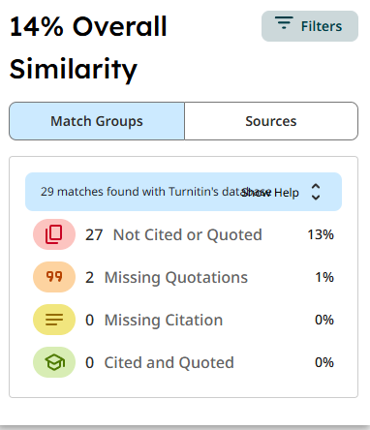

# Introduction

The second coursework task of the Digital Media Project module is worth 50% of the final mark. The project with its entire documentation system that is allocated to students requires them to submit research findings and planning data and project aims and technology details and production process documentation from pre-production to production and post-production. The process requires user testing as well as gathering suitable evidence from findings. Students prepared a research for the purpose of choosing a client in the first phase of coursework of their selected project. My selected activity was the task of creating an awareness animated video for ward no. 11.

## Topic

**‘Dengue’**

This project video was developed for Ward 11, with a focus on community needs and identifying challenges through content. It is about dengue fever, which is transmitted by mosquito bites. The infection produces a variety of symptoms, including high fever, nausea, and joint and muscular discomfort. There is no particular therapy for dengue, thus this project video was created to educate people about the disease and its preventions and treatments.

## Area of Research

The primary topic of research has been determining how to create an appropriate animated awareness film for dengue disease. Considering each research, I learned about how dengue spreads, what its symptoms are, how to prevent it, what the causes of dengue are, and why we just need to treat it. I also explored numerous animation styles, methodologies, and technologies to find the most practical approach to present information that is simple, intelligent, and instructive. (Muntasir, 2017)

Some of the topics are:

* Animation in education
* Health research
* Understanding the clients
* Targeting audiences
* Motion graphics awareness storytelling

# Aims of Project

This project's goal is to develop a visually beautiful and message-rich animated movie that educates people about dengue fever, including its causes, symptoms, prevention, and the necessity of early treatment. The film will demystify health information in graphics, allowing people to spot early warning symptoms, learn preventative behaviours, and take measures to slow disease spread. It is intended to be simple to comprehend, quickly transmitted, and successful, particularly among children and high-risk populations.

**Purpose of the Project:**

* Educate the public about dengue transmission and prevention methods.
* Encourage behaviour modification through daily behaviours such as removing stagnant water and employing repellents.
* Animated messages will make medical information more relevant and accessible to kids and families.

**Why It Will Be Useful:**

* Animated films are more engaging and memorable than text, particularly for youngsters, and provide valuable information.
* Video is readily shared in schools, community organizations, and on social media.
* Visual communication facilitates adaption to diverse languages across borders.

# Target Audience

**Age: 10 – 60 years old**

* Adolescents and children (10-18) are most vulnerable to Aedes mosquito bites due to their frequent outside activities, particularly in the morning and evening.
* Young folks aged 19-40 are the most active, mobile, and internet users.
* Older individuals (60 and under) have important roles as caretakers and decision-makers in families and communities, making them crucial for promoting preventative behaviour and information sharing.

**Gender: All genders**

* Dengue virus does not distinguish gender. Awareness must spread to everyone so that prevention, a collective endeavour, may be accomplished—swabbing dwellings, spraying repellents, and providing early treatment.
* Engage both genders to effectively communicate with caregivers and victims.

**Ethnicity: No specific ethnicity**

* Dengue does not discriminate depending on ethnicity. Making the information culturally neutral or adaptable ensures that it may be used in multi-ethnic areas, particularly varied countries.
* Localizing characters and language in animations can improve accessibility in some places.

**Location: Urban and semi-urban areas**

* The climatic conditions in these places are conducive to a high prevalence of dengue, with quiet water and favorable temperatures.
* Urban residents are more vulnerable to mosquitos due to population density, water storage practices, and garbage accumulation, all of which serve as breeding grounds.

# Product Research

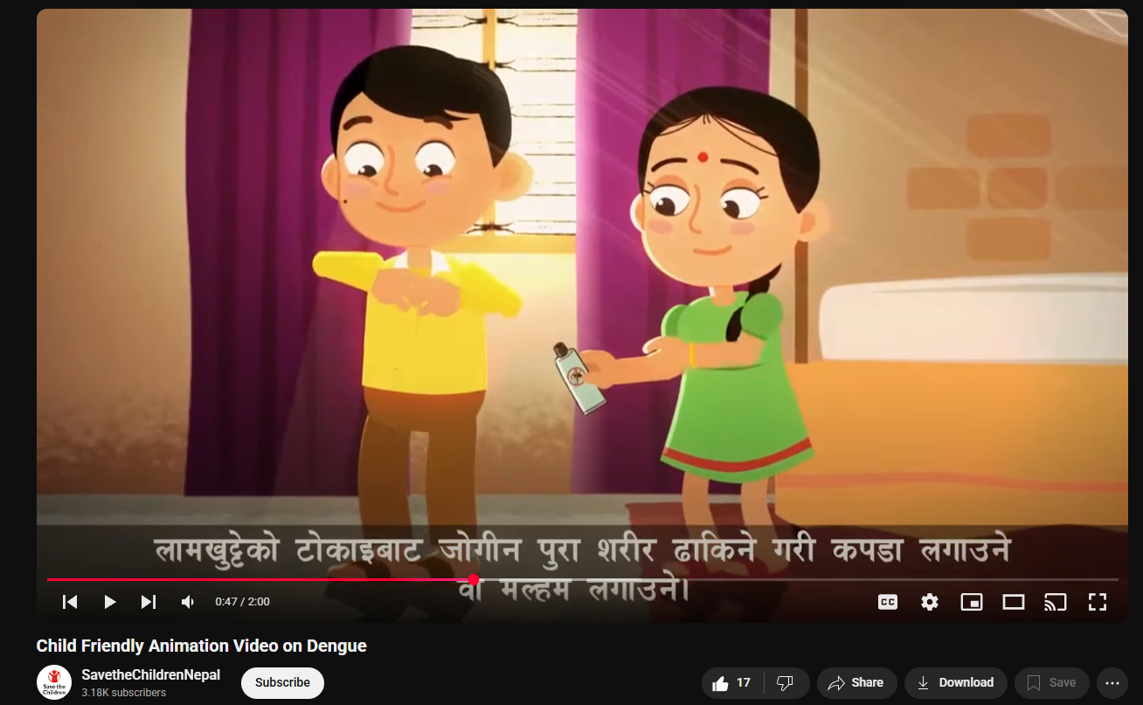

Figure 1

<https://www.youtube.com/watch?v=eyFyQcgOFp0&list=LL&index=6&ab_channel=SavetheChildrenNepal>

This animated short produced by Save the Children Nepal attempts to educate people about dengue sickness. It focuses on the disease's ethology, symptoms, and preventative measures. The film emphasizes how to keep the environment clean, minimize standing water places, and use mosquito nets and repellents as preventative measures to decrease mosquito breeding and bites. The video's realistic imagery and straightforward narrative seek to raise awareness and motivate action to combat the spread of dengue among the population.

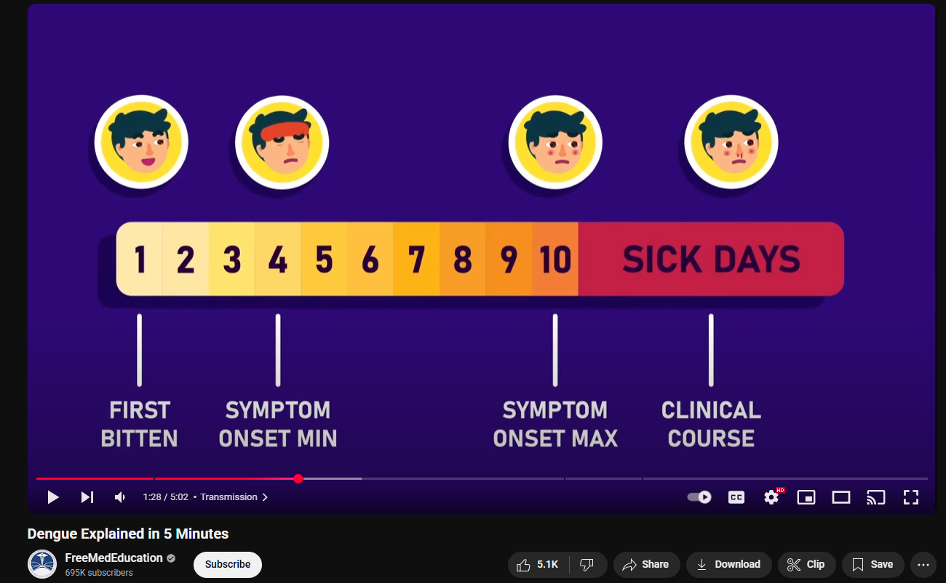

Figure 2

<https://www.youtube.com/watch?v=Ai9VZRIUN94&t=167s&ab_channel=FreeMedEducation>

The movie stood out because of its outstanding After Effects animation, which gave the content a professional and polished appearance. The motion graphics were properly tuned to flow with the plot, making the film more informative and message-driven. This displayed the full potential of animation, when combined with well-planned sound storytelling, to capture people's attention and communicate a message.

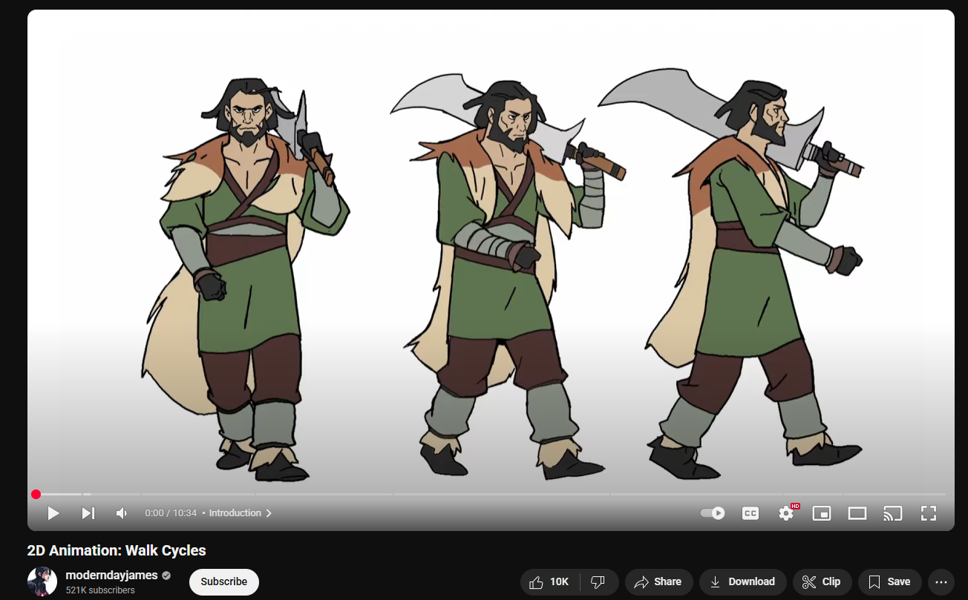

Figure 3

<https://www.youtube.com/watch?v=IViMJyqU9gY&ab_channel=moderndayjames>

The video named "2D Animation: Assisting artists." ModernDayJames uses a comprehensive learning method to teach students how to create realistic walk cycles in two-dimensional animation. James walks students through the process of replicating genuine footwork animation effects. He demonstrates how to break the procedure into small pieces and discusses how this impacts your character's natural walking motion. Our training is suitable for both new and experienced animators who want to master specialized 2D character animation techniques.

# Technologies Employed

* **Fire Alpaca**

Fire Alpaca advertises itself as a free digital painting program that offers both simplicity and great performance. The software has functionality similar to Adobe Photoshop, Illustrator, and CorelDRAW. (helyer, 2023)

* **Adobe illustrator**

Adobe Illustrator, which was developed in 1987, has evolved into a leading software platform for producing vector graphics. Illustrator from Adobe provides new capabilities to let users create designs for drawings, logos, and icons, as well as typography and other artwork components. (Mitchell, 2021)

* **Adobe After Effects**

Adobe After Effects, a video animation, motion graphics, and special effects program, allows users to create effects for YouTube content, broadcast videos, and marketing presentations. The program offers multimedia visual optimization capabilities for delivering improved content across many media channels, including cinema and television, online, and in-store displays. (alexander, 2023)

* **Adobe Premier pro**

Premiere Pro, developed by Adobe Systems, is a video editing tool that can be used on videos and commercials, as well as television programs and web material. Users can use the built-in audio editing tools. Premiere Pro is available as a standalone application or as part of the Adobe Creative Cloud suite. (Smith, 2024)

* **Toon boom harmony**

Toon Boom Harmony is an animation production program that provides enhanced capabilities for visual creators working on films, television shows, internet series, commercials, video games, and other projects. (Harmony 20 Essentials, n.d.)

# Project Plan

The chart was created in the fifth semester, however owing to client concerns and other reasons, it is being postponed.

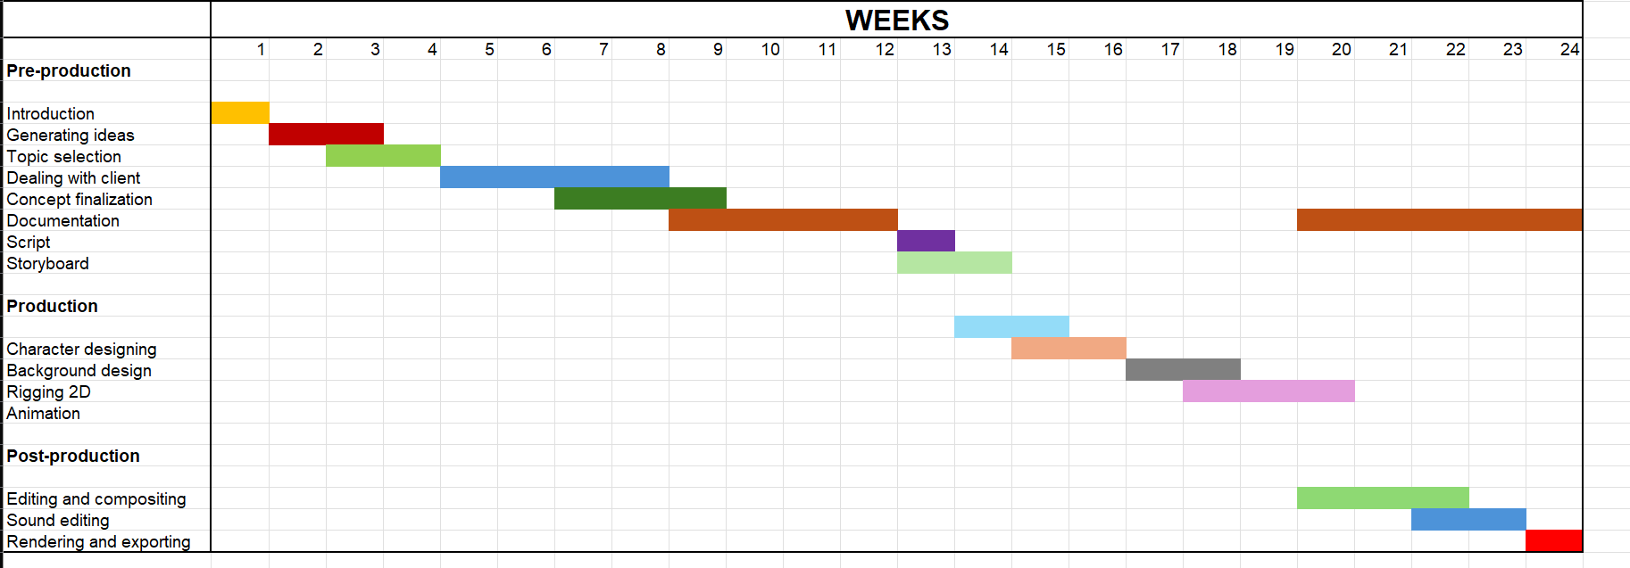

Figure 4

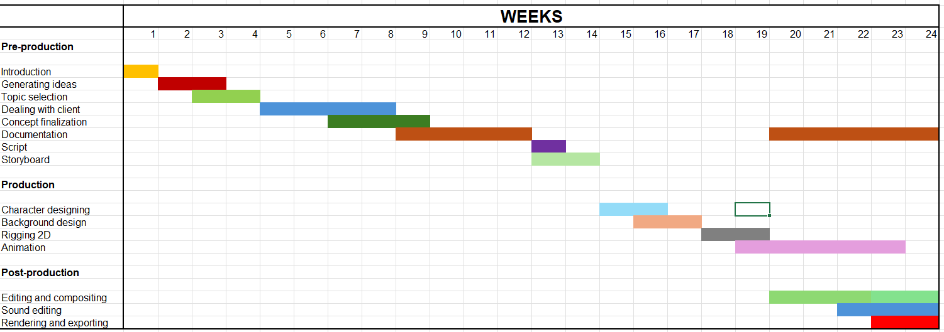

Figure 5

# Production Phases

## Pre-production

### Script

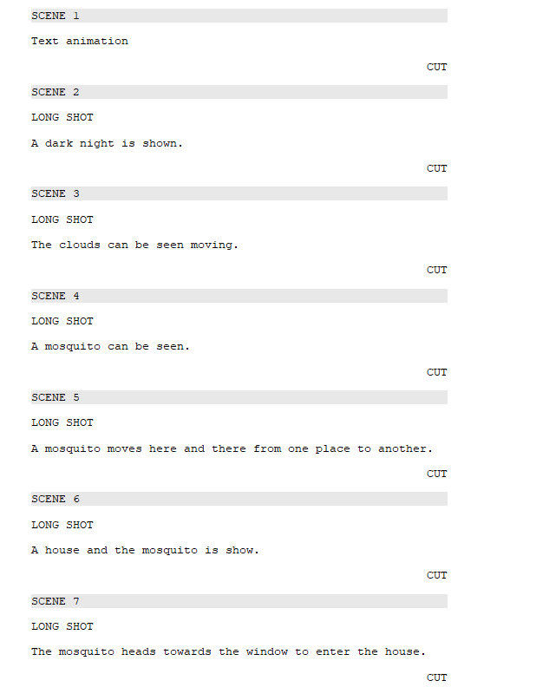

Figure 6 Script

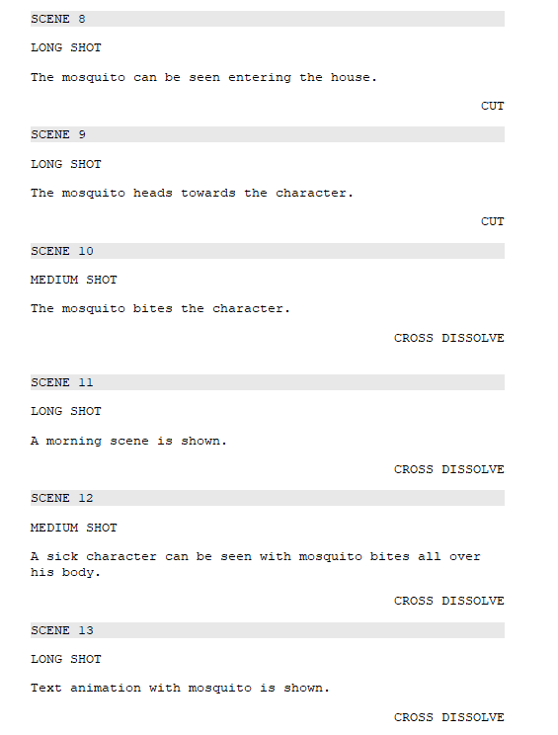

Figure 7 Script 1

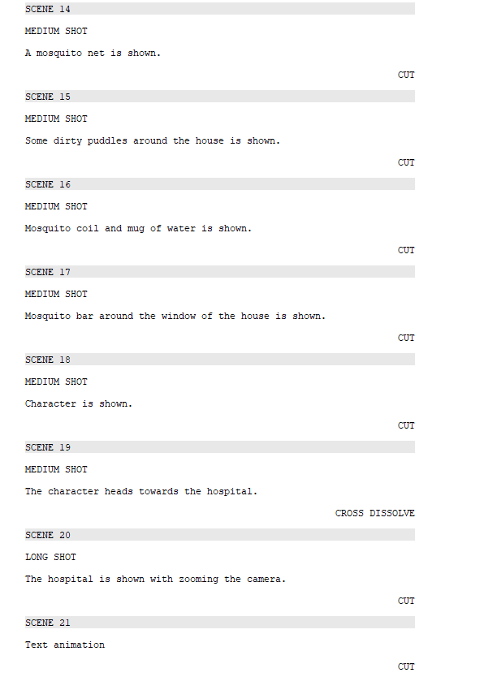

Figure 8 Script 2

### Storyboard

|  |  |  |  |  |  |
| --- | --- | --- | --- | --- | --- |
|  | |  | | --- | | Scene 1 | | Shot: Long shot | | Time: 3 sec | | Description: Text animation | |
|  | |  | | --- | | Scene 2 | | Shot: Long shot | | Time: 2 Sec | | Description: A dark night is shown. | |
|  | |  | | --- | | Scene 3 | | Shot: Long shot | | Time: 2 Sec | | Description: The clouds can be seen moving. | |
|  | |  | | --- | | Scene 4 | | Shot: Long shot | | Time: 2 Sec | | Description: A mosquito can be seen. | |
|  | |  | | --- | | Scene 5 | | Shot: Long shot | | Time: 2 Sec | | Description: A mosquito moves here and there from one place to another. | |
|  | |  | | --- | | Scene 6 | | Shot: Long shot | | Time: 3 Sec | | Description: A house and the mosquito is show. | |
|  | |  | | --- | | Scene 7 | | Shot: Long shot | | Time: 2 Sec | | Description: The mosquito heads towards the window to enter the house. | |
|  | |  | | --- | | Scene 8 | | Shot: Long shot | | Time: 2 Sec | | Description: The mosquito can be seen entering the house. | |
|  | |  | | --- | | Scene 9 | | Shot: Long shot | | Time: 4 sec | | Description: The mosquito heads towards the character. | |
|  | |  | | --- | | Scene 10 | | Shot: Medium shot | | Time: 3 sec | | Description: The mosquito bites the character. | |
|  |  |
|  | |  | | --- | | Scene 11 | | Shot: Long shot | | Time: 3 sec | | Description: A morning scene is shown. | |
|  | |  | | --- | | Scene 12 | | Shot: Medium shot | | Time: 11 sec | | Description: A sick character can be seen with mosquito bites all over his body. | |
|  | |  | | --- | | Scene 13 | | Shot: Long shot | | Time: 5 sec | | Description: Text animation with mosquito is shown. | |
|  | |  | | --- | | Scene 14 | | Shot: Medium shot | | Time: 6 sec | | Description: A mosquito net is shown. | |
|  | |  | | --- | | Scene 15 | | Shot: Medium shot | | Time: 5 sec | | Description: Some dirty puddles around the house is shown. | |
|  | |  | | --- | | Scene 16 | | Shot: Medium shot | | Time: 8 sec | | Description: Mosquito coil and mug of water is shown. | |
|  | |  | | --- | | Scene 17 | | Shot: Medium shot | | Time: 8 sec | | Description: Mosquito bar around the window of the house is shown. | |
|  | |  | | --- | | Scene 18 | | Shot: Medium shot | | Time: 5 sec | | Description: Character is shown. | |
|  | |  | | --- | | Scene 19 | | Shot: Medium shot | | Time: 5 sec | | Description: The character heads towards the hospital. | |
|  | |  | | --- | | Scene 20 | | Shot: Long shot | | Time: 5 sec | | Description: The hospital is shown with zooming the camera. | |
|  | |  | | --- | | Scene 21 | | Shot: Long shot | | Time: 3 Sec | | Description: Text animation | |

## Production

### Designing

Designing the character is a crucial part of animation where the character play a vital role in portraying the message.

### Layout

Pre-designing the background layout prior to initiating the animation process is a crucial step in the development of immersive settings. (toonz, n.d.)

### Rigging

This is the important step in the development of animation where the characters are rigged to its key frame animation.

### Animation

This technique consists of creating the postures and movements necessary to record the performance of the character when animating. The keyframes are the starting point, maintaining the most important times and intervals (toonz, n.d.).

## Post-production

### Editing

In the last stages, the animation is edited to improve the timing, pace, and general narrative flow of the story. The editor closely collaborates with the creative group in order to finesse the animation so that each scene transitions smoothly and effectively. (toonz, n.d.)

### Sound

The use of sound design is very crucial in furthering narration. Sound designers make and incorporate the sound effects, ambient sounds, and background scores to give the full immersive listening experience. Music and background score in animation are very important features that add richness to storyline and create emotions. (toonz, n.d.)

### Rendering

After all final visual and audio edits are completed, the whole animation is played out. This allows the team to view the animation in totality and select any problems or inconsistencies that need fixing. It is a final quality check prior to the animation being ready for rendering. (toonz, n.d.)

# Resources

## Software used

* **Fire Alpaca**
* **Adobe Illustrator**
* **Adobe After Effects**
* **Adobe Premier Pro**
* **Toon boom**
* **Excel**



Figure 9 Software

## Hardware used

### Laptop

Processor: 11th Gen Intel(R) Core (TM) i7-11800H @ 2.30GHz 2.30 GHz

Graphics card: NVIDIA GeForce RTX 3070 Laptop GPU

RAM: 16GB

### Graphic tablet

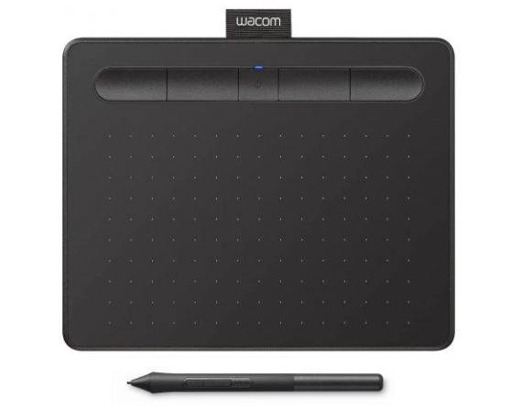

Figure 10 (Gadgets house nepal, n.d.)

Used for designing backgrounds, characters and colouring it.

## Website used

* **YouTube**
* **Pixabay**
* **Pinterest**



Figure 11 Websites

# User Testing & Findings

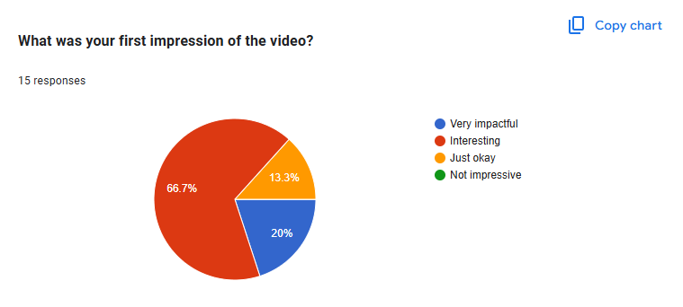

Figure 12

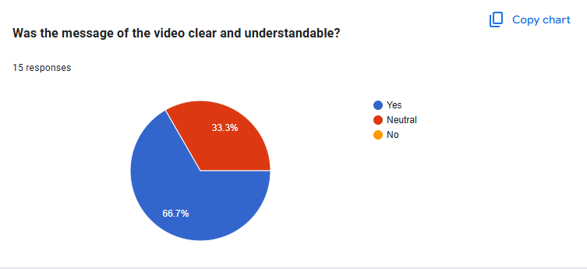

Figure 13

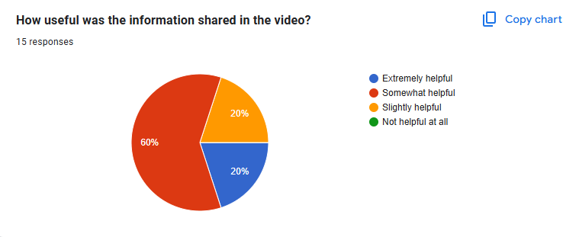

Figure 14

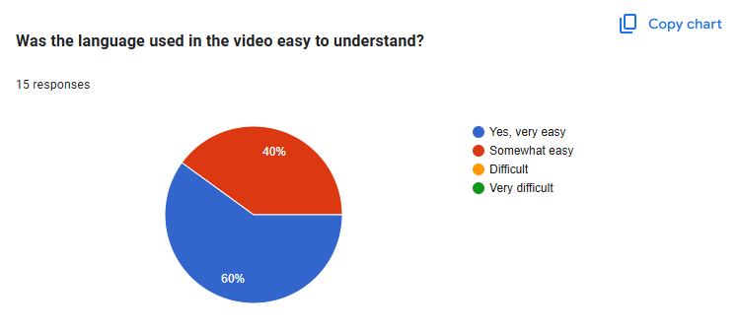

Figure 15

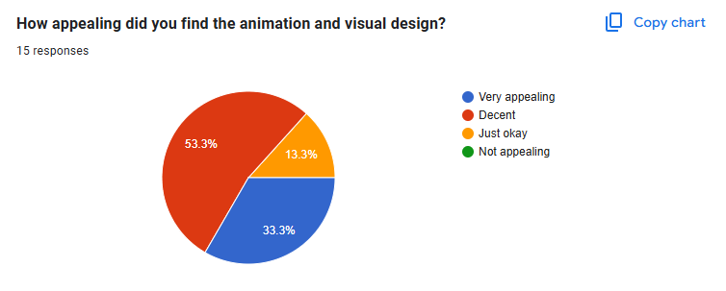

Figure 16

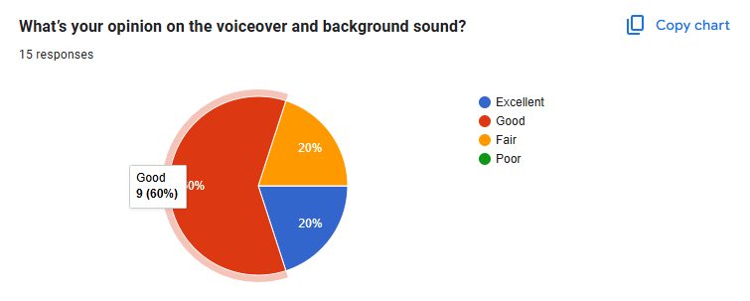

Figure 17

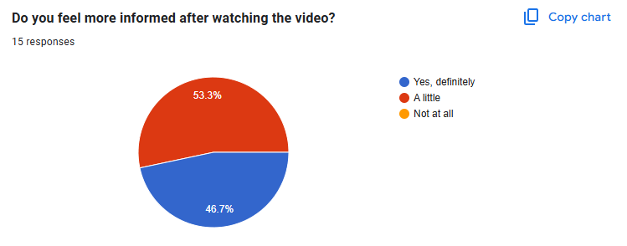

Figure 18

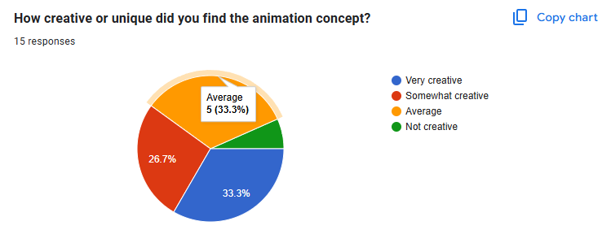

Figure 19

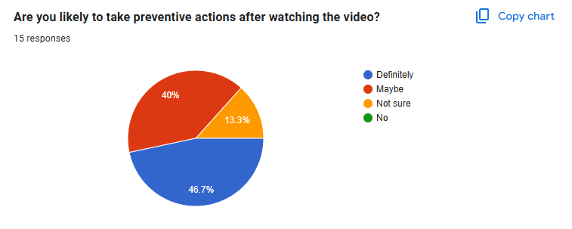

Figure 20

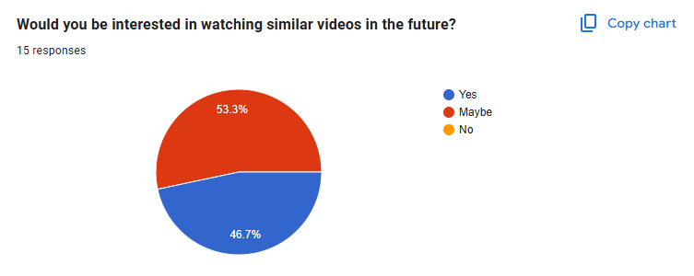

Figure 21

# Conclusion

In this assignment, students must focus on a single topic and demonstrate their knowledge and skills acquired during the year. So, for my DMP project, I chose to create an awareness cartoon movie. This documentation covers the research, client acquisition, pre-production, production, and post-production phases. It also comprises user testing and surveys, followed by a conclusion.

As a result, this project was finished effectively by creating an animated awareness movie to educate people about the disease 'Dengue'. The documentation included all aspects of the project, including research, manufacturing phases, software utilized, customer approval, and tools and designs for the final product. The animated film also provides messages regarding symptoms and prevention methods in an instructive and entertaining manner, assisting in successfully teaching the targeted audiences.

Finally, I'd like to thank my internal and external supervisors, Mr. Bijay Shakya sir and Ms. Aarsha Maharjan ma'am, for their direction and assistance during the project.

# References

alexander, H., 2023. *envato.* [Online]   
Available at: https://elements.envato.com/learn/after-effects-tutorials-beginners?adposition=&gad_source=1&gad_campaignid=19579623273&gbraid=0AAAAADclSXnIkGGN-IlKwx18_1JNCg92U&gclid=Cj0KCQjww-HABhCGARIsALLO6XxneJo7hnG8TfAVfQ8Uk3gGeMXD0KN5bl3rF5TZ6rYAL69GgInmsDEaAss-EAL  
[Accessed 6 May 2025].

Gadgets house nepal, n.d. *Gadgets house nepal.* [Online]   
Available at: https://gadgethousenepal.com/product/wacom-intuos-bluetooth-graphics-drawing-tablet/  
[Accessed 6 May 2025].

Harmony 20 Essentials, n.d. *Harmony 20 Essentials.* [Online]   
Available at: https://docs.toonboom.com/help/harmony-20/essentials/about/about.html#:~:text=Toon%20Boom%20Harmony%20Essentials%20is,games%20and%20many%20other%20productions.  
[Accessed 6 May 2025].

helyer, R., 2023. *Make use of.* [Online]   
Available at: https://www.makeuseof.com/what-is-firealpaca-paint-software/#:~:text=FireAlpaca%20is%20a%20digital%20art,tutorials%20for%20using%20its%20software.  
[Accessed 6 May 2025].

Mitchell, D., 2021. *udemy.* [Online]   
Available at: https://blog.udemy.com/what-is-adobe-illustrator-used-for/?utm_source=adwords&utm_medium=udemyads&utm_campaign=Search_DSA_GammaCatchall_NonP_la.EN_cc.ROW-English&campaigntype=Search&portfolio=ROW-English&language=EN&product=Course&test=&audience=DSA&topic  
[Accessed 6 May 2025].

Muntasir, 2017. *iedunote.* [Online]   
Available at: https://www.iedunote.com/health-research/  
[Accessed 6 May 2025].

Smith, C., 2024. *American graphics institute.* [Online]   
Available at: https://www.agitraining.com/adobe/premiere-pro/classes/what-is-premiere-pro?srsltid=AfmBOor2TZiZCuo8cgvfo_HTP9CWHlVxMuTBZWkyPBWQg5X76mIVjgsm  
[Accessed 6 May 2025].

toonz, n.d. *toonz.* [Online]   
Available at: https://toonz.co/2023/06/26/behind-the-scenes-a-sneak-peek-into-the-animation-production-pipeline/  
[Accessed 6 May 2025].

# Appendix

## Gantt Chart



Figure 22 gantt chart



Figure 23 Gantt chart 2

## Approval letter

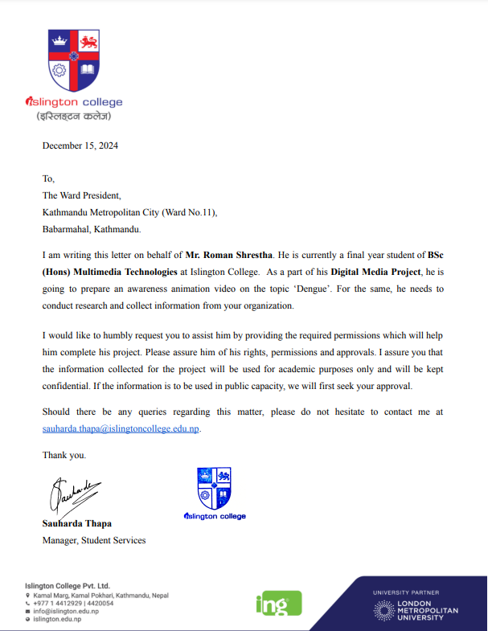

Figure 24 college letter

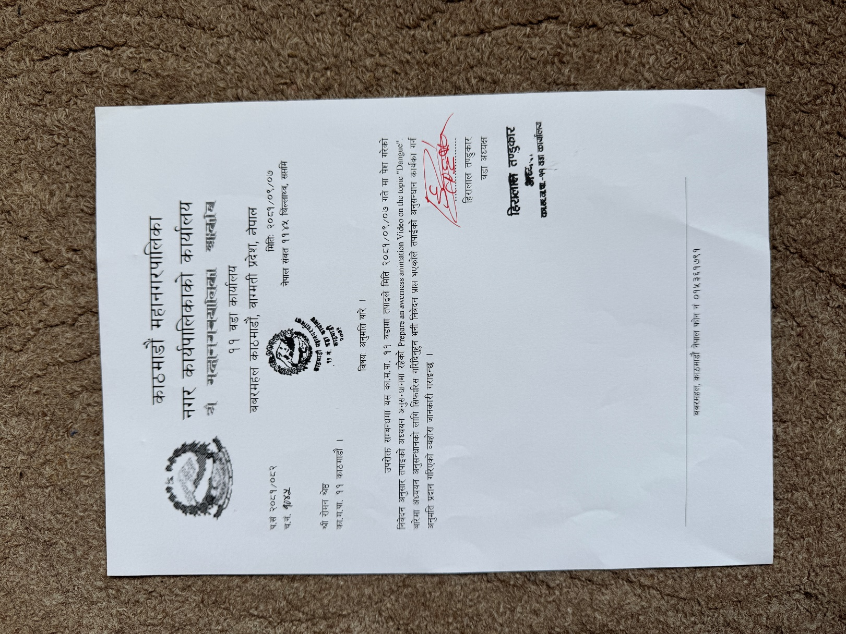

Figure 25 client letter

## Log sheet

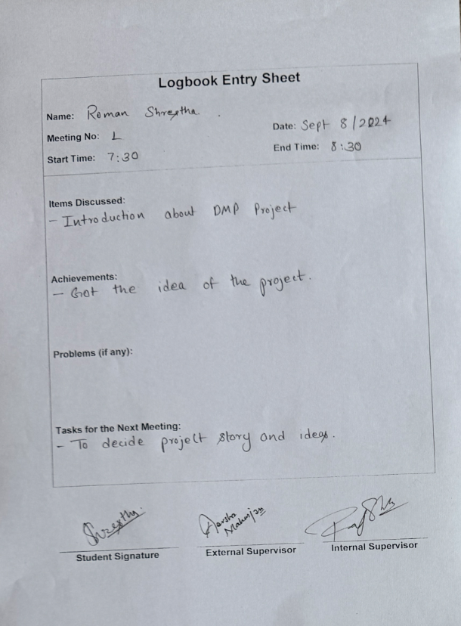

Figure 26 Log sheet 1

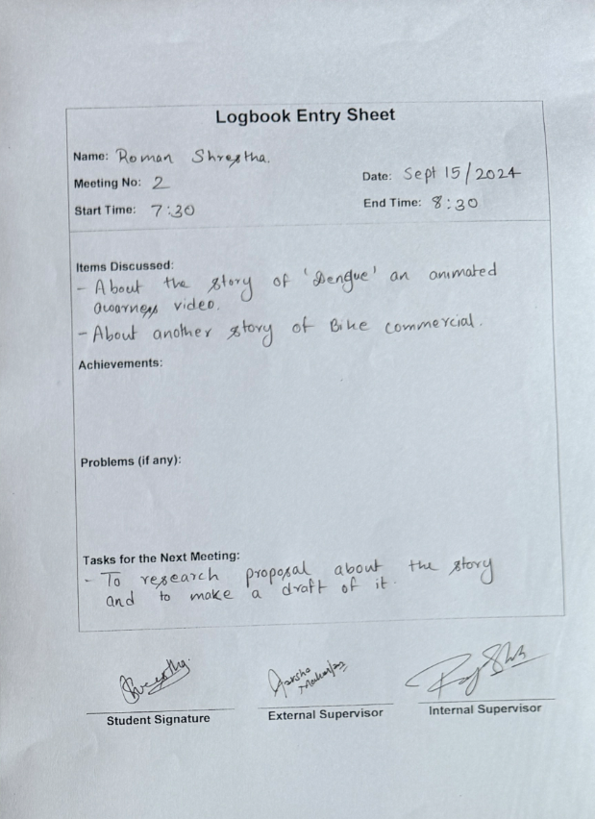

Figure 27 Log sheet 2

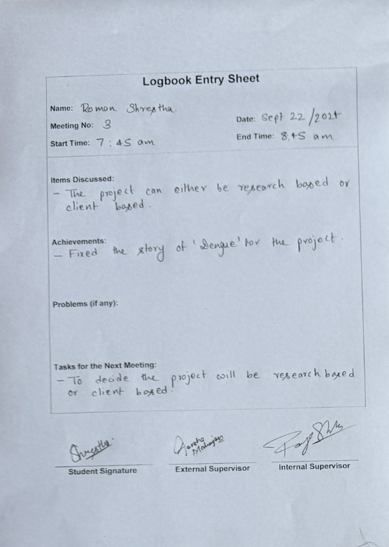

Figure 28 Log sheet 3

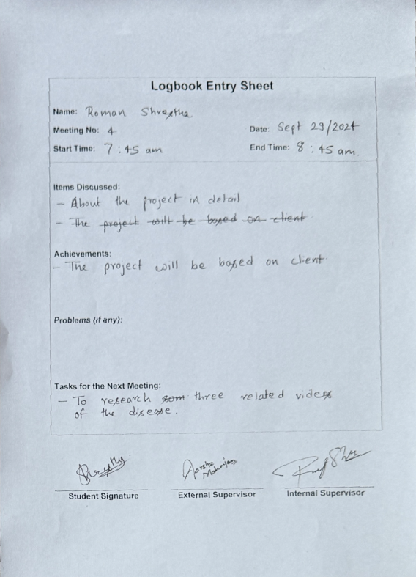

Figure 29 Log sheet 4

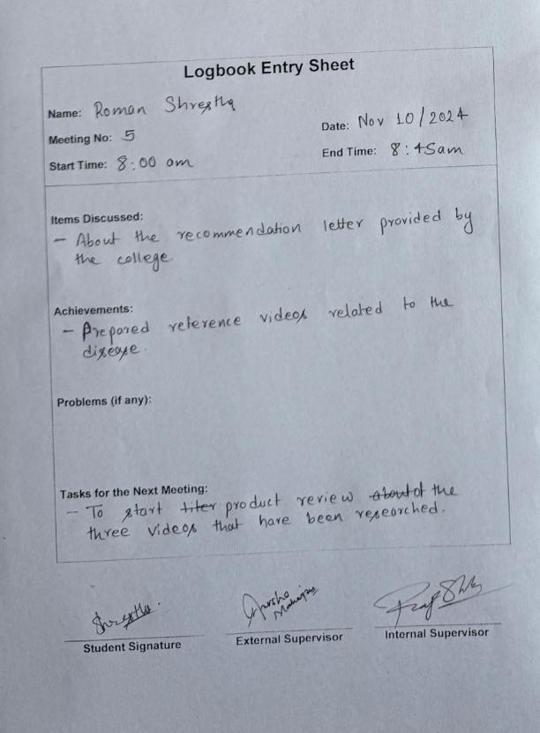

Figure 30 Log sheet 5

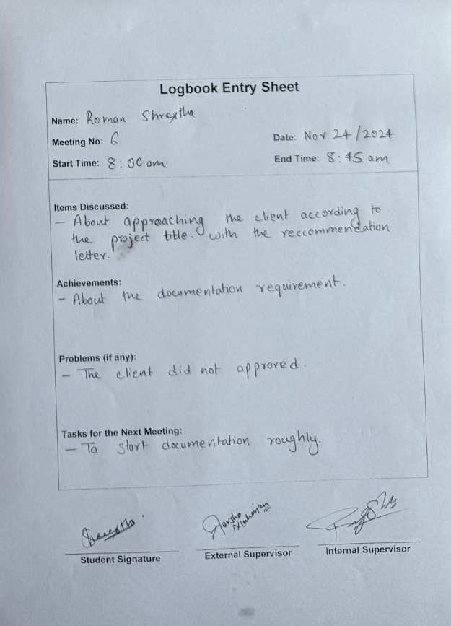

Figure 31 Log sheet 6

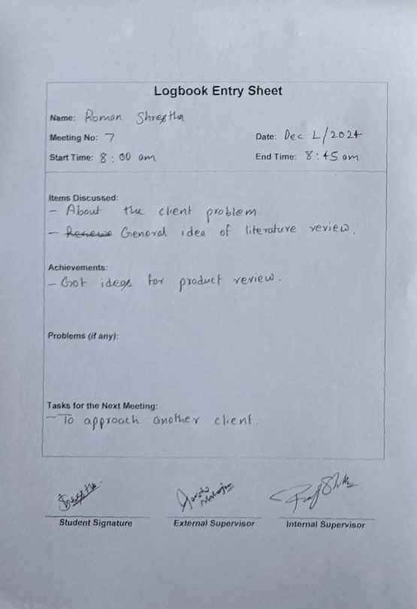

Figure 32 Log sheet 7

e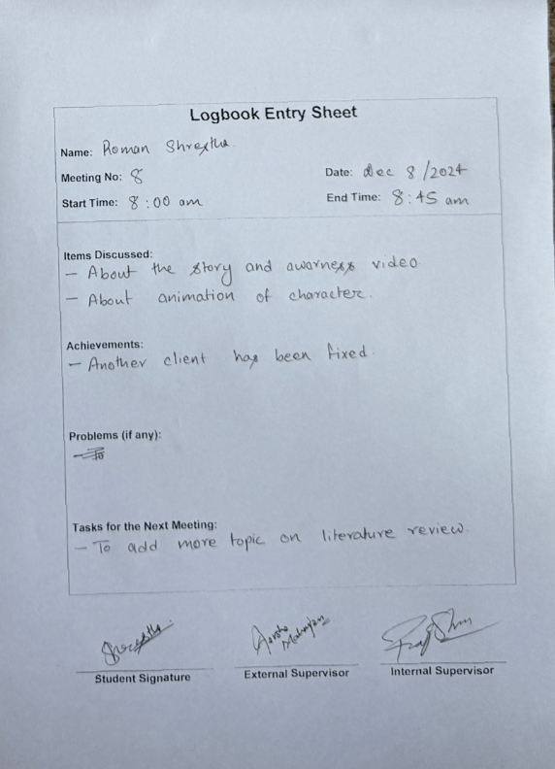

Figure 33 Log sheet 8

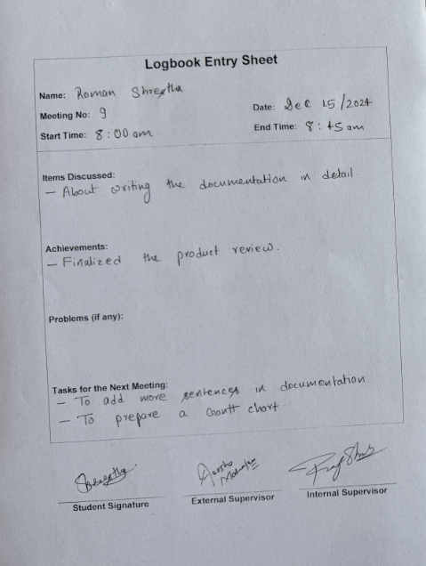

Figure 34 Log sheet 9

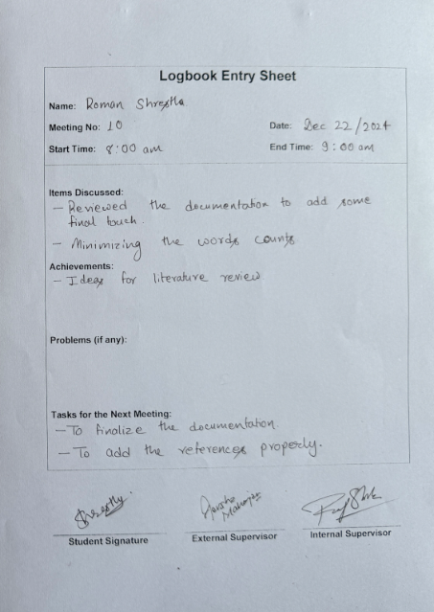

Figure 35 Log sheet 10

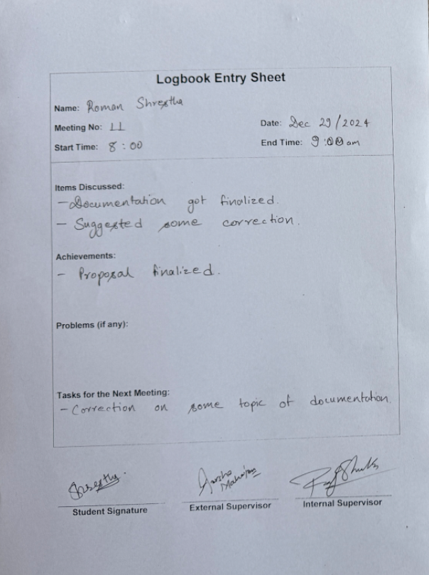

Figure 36 Log sheet 11

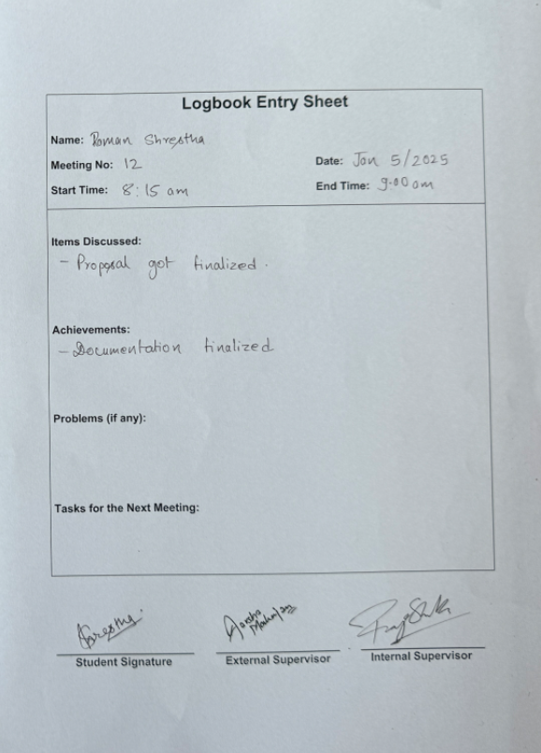

Figure 37 Log sheet 12

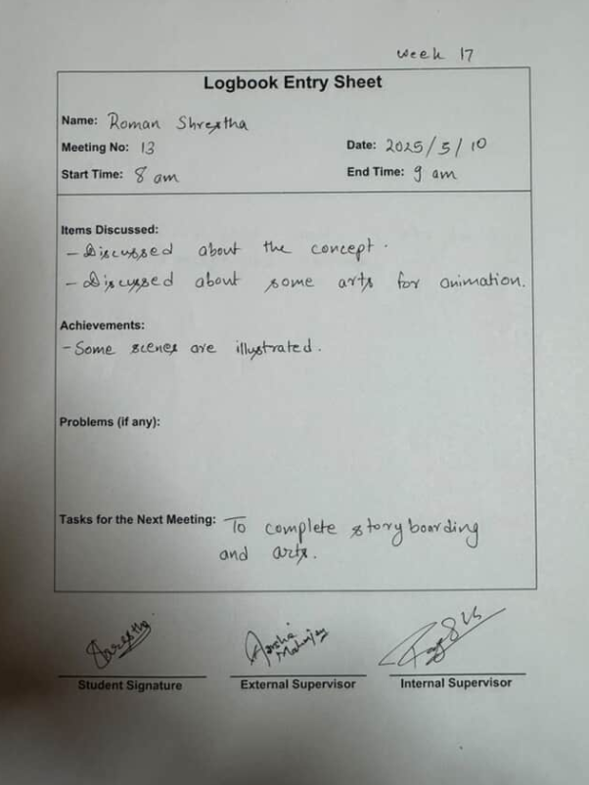

Figure 38 Log sheet 13

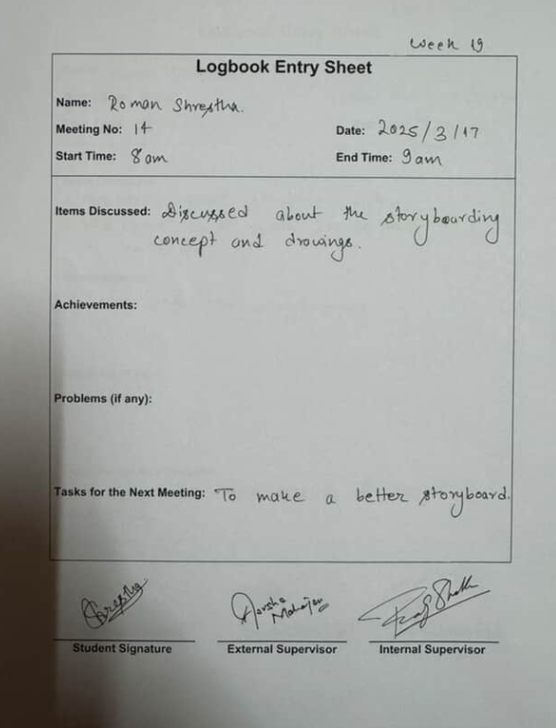

Figure 39 Log sheet 14

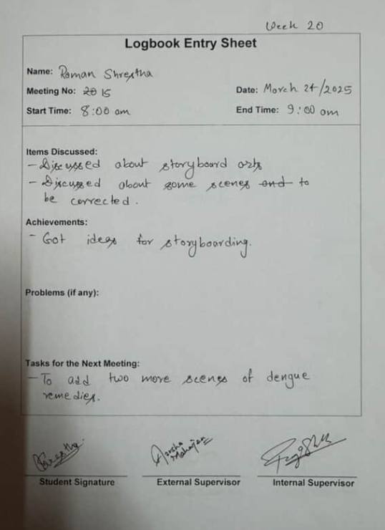

Figure 40 Log sheet 15

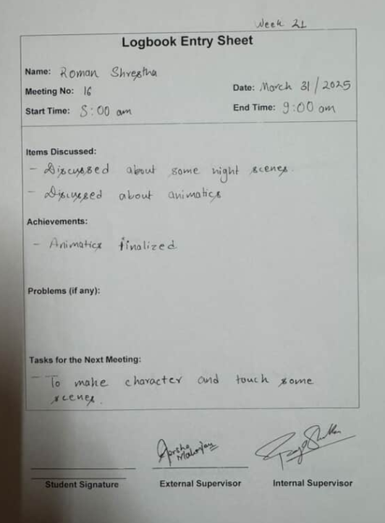

Figure 41 Log sheet 16

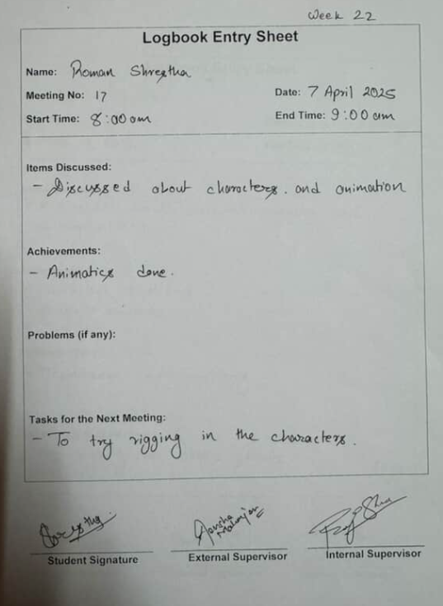

Figure 42 Log sheet 17

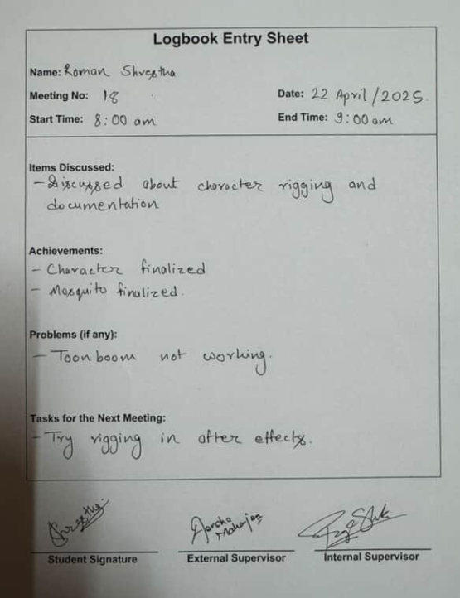

Figure 43 Log sheet 18

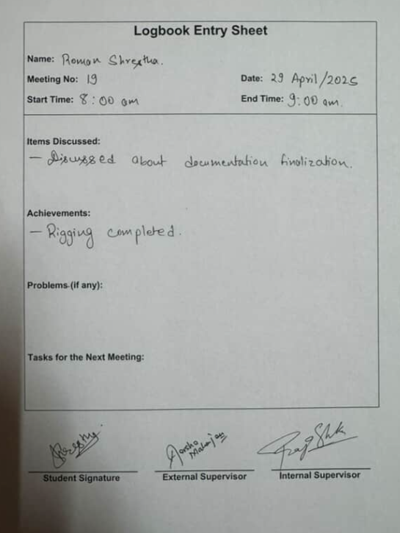

Figure 44 Log sheet 19